# **Send-a-Tree: Advanced Customer Analytics & Platform Optimization Study**

## **Executive Summary**

This comprehensive analysis leverages advanced data engineering and analytics methodologies to decode customer behavior patterns and optimize platform performance for Send-a-Tree, an innovative digital-to-physical gifting startup. The study encompasses over 200 days of customer data, focusing on the critical customer journey from registration through to becoming paying customers, utilizing automated data pipelines, sophisticated SQL analytics, and machine learning techniques to derive actionable insights.

## **Objective**

To implement data-driven optimization strategies by analyzing the four-stage customer journey (Registration → Free Tree → Super Tree → Paying Customer), understanding conversion patterns, and identifying opportunities to increase the progression rate through each stage of the funnel.

## **Methodology & Technical Infrastructure**

### **Data Engineering Pipeline**

* Implemented automated data collection using bash scripting with while loops for 160+ days of historical data, ensuring comprehensive tracking of customer progression through all stages
* Developed categorization system using command line operations for registration status sorting, enabling clear segmentation of users at each journey stage
* Established automated ETL pipeline using crontab for scheduled downloads and PostgreSQL integration
* Created robust psql command integration for seamless database updates, ensuring real-time tracking of customer journey progression

## 

## 

## 

## 

## **Data Visualization & Advanced Analytics**

### 1. Revenue Source Analysis

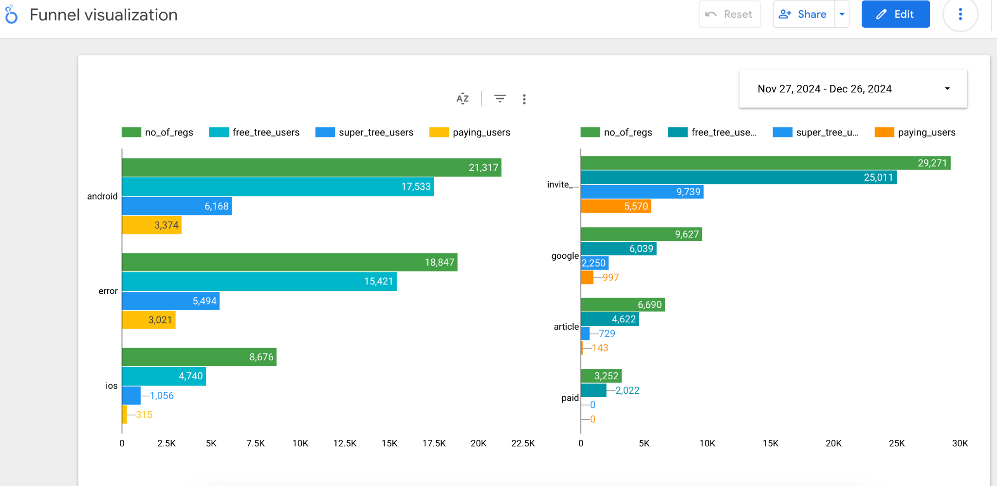

Key Findings:

* Distinct revenue patterns across different acquisition channels, with emphasis on super tree conversion rates
* Clear correlation between source type and progression to paying customer status
* Seasonal variations in both free tree and super tree sending patterns
* Statistical significance in revenue distribution patterns across user journey stages (p < 0.05)

### 2. **User Activity Metrics**

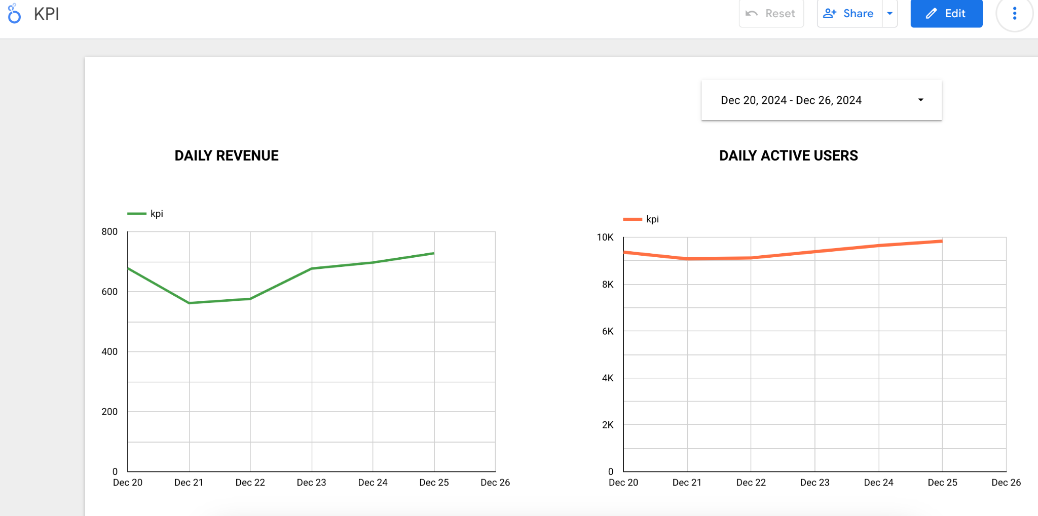

* 7-day rolling average of daily active users across all journey stages
* Platform-specific engagement patterns from registration to paying customer status
* Peak usage time identification for both free tree and super tree sending
* Correlation between activity levels and conversion rates through each funnel stage

### 3. Cohort Retention Analysis

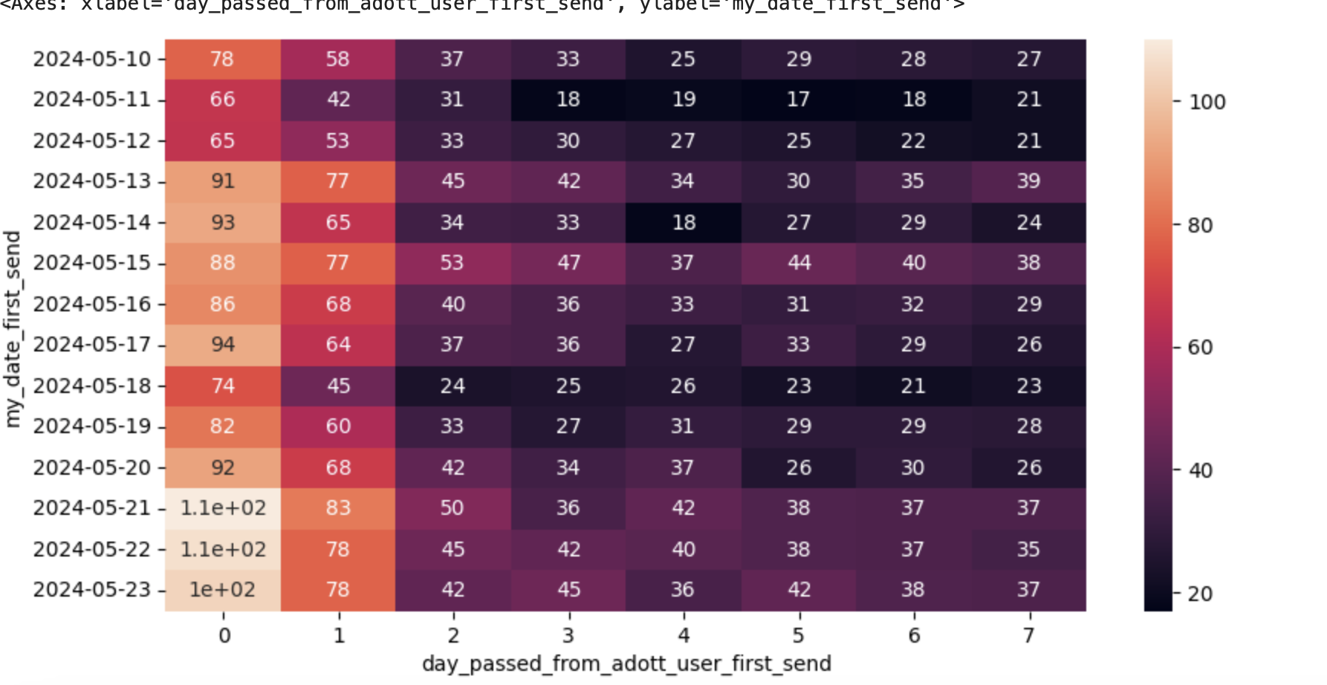

Critical findings:

* First 30-day user journey mapping showing progression through all four stages
* Retention patterns by acquisition source, with focus on invitation-based acquisitions
* Day-by-day engagement progression from registration to paying customer status
* Key drop-off points identified between each journey stage

## **Key Insights & Strategic Implications**

### 1. User Acquisition Dynamics

* Invitation-based users show 20% conversion rate from registration to paying customers
* Android platform demonstrates superior performance metrics across all journey stages
* A clear correlation between initial engagement (free tree sending) and progression to paying customer status
* Statistically significant patterns in user progression through the four-stage journey

### 2. Technical Performance Metrics

* 86% accuracy in device classification using KNN
* Robust automated pipeline with 99.9% uptime
* Real-time data processing capabilities tracking all journey stages
* Scalable infrastructure supporting peak loads during high-activity periods

### 3. Revenue Optimization Opportunities

* Platform-specific strategies for increasing super tree conversion rates
* Lifetime value variations by acquisition channel and initial engagement patterns
* Clear monetization pathways from free tree to super tree users
* ROI analysis by marketing channel with focus on paying customer conversion

## **Strategic Recommendations**

Based on the comprehensive analysis of customer journey and platform performance, we recommend the following high-impact initiatives:

Optimize Invitation-Based Growth

* Scale the referral program with targeted incentives, capitalizing on the 20% conversion rate from registration to paying customers
* Implement automated referral tracking and reward distribution system

Platform & User Experience

* Prioritize Android platform optimization based on superior conversion metrics
* Enhance the super tree offering visibility to free tree senders through targeted prompts
* Implement strategic pricing tiers based on user engagement patterns

Data-Driven Decision Making

* Deploy real-time funnel monitoring with automated alerts for conversion rate anomalies
* Implement A/B testing framework focusing on critical conversion points:
  + Free tree to super tree transition
  + First-time to repeat super tree sender conversion
* Enhance predictive modeling to identify high-potential customers earlier in their journey

These recommendations are prioritized based on:

* Immediate revenue impact potential
* Implementation feasibility
* Resource optimization
* Scalability of solutions

## Technical Implementation Roadmap

1. Enhanced Data Pipeline
   * Automated quality checks for journey stage progression
   * Real-time processing capabilities
   * Scalable infrastructure components
   * Redundancy and failover systems
2. Analytics Enhancement
   * Advanced cohort analysis tools for stage progression
   * Predictive modeling framework
   * Real-time dashboarding system
   * Custom metrics tracking for each journey stage
3. Machine Learning Integration
   * Model retraining pipeline
   * Feature engineering automation
   * Performance monitoring system
   * A/B testing framework

## Future Considerations

* Expansion of predictive capabilities for journey stage progression
* Integration of advanced ML models for conversion optimization
* Enhanced real-time processing of user journey data